

Goetre Primary School
Positive Behaviour Policy

Vision
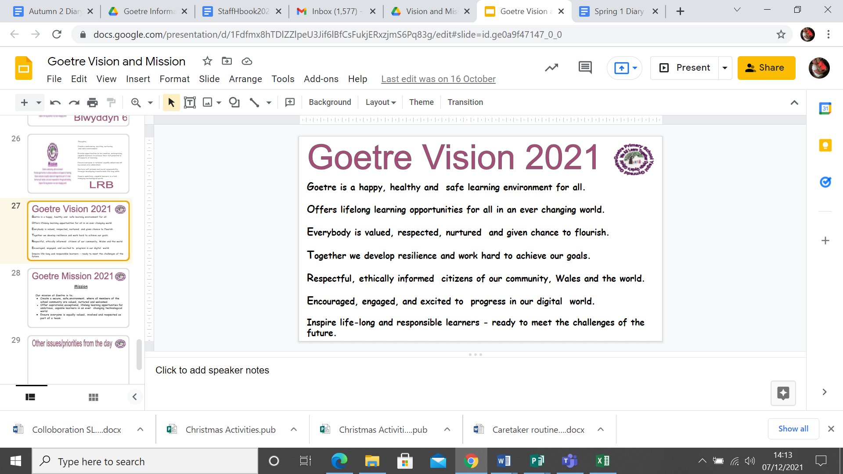

Mission Statement
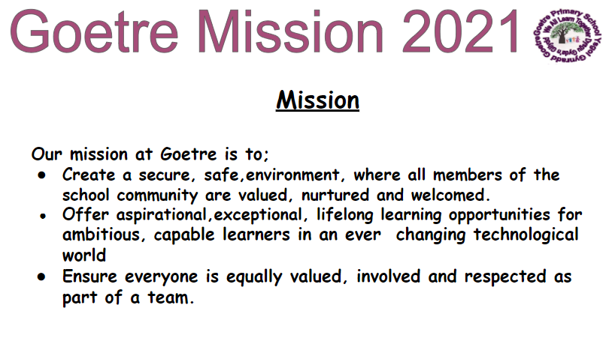

Values

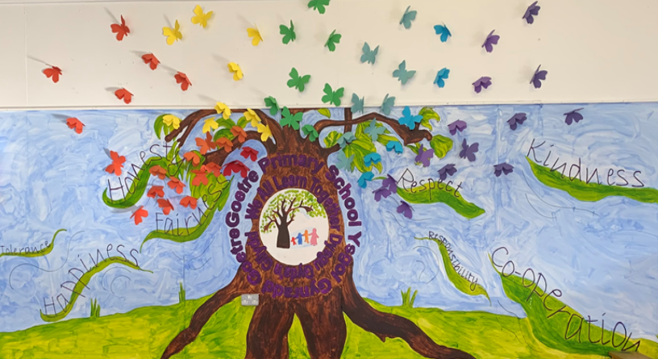

‘Schools can and do make a difference. They have the capacity to lead, support and encourage pupils in developing good behaviour and in learning to play a responsible role both within school and in the wider world.’ (Elton Report)

Rationale
All staff at Goetre Primary School are committed to the belief that the school does not ‘just expect pupils to behave well’, but that we have a responsibility through our ethos and organisation to positively encourage the desired behaviours.We understand that all behaviour is communication and sometimes these behaviours are reflective of their lives outside school. The children bring to school a wide variety of behavioural patterns based on differences in home values, culture, attitudes and parenting skills. As a school we must therefore work towards standards of behaviour based on the basic principles of:
honesty, respect, co-operation, kindness, tolerance, consideration, self discipline, independence and responsibility.

The school accepts and strives towards standards of behaviour, which reflects these principles. To enable all pupils to become active participants in the learning process, all pupils need to develop the Personal and Social Skills necessary to achieve this. The children's learning must be understood developmentally and the school acknowledges that as with other skills, pupils are at different stages of skill development in PSE and need therefore to be placed on a continuum at the appropriate level in order to provide the applicable level of skill to ensure progress is sustained and behavioural skills are taught.

At Goetre Primary School, we will determine the boundaries of acceptable and unacceptable behaviours and the procedures that will come into force if behaviour is deemed unacceptable and the hierarchy of rewards and sanctions which will support this. We wish to maintain a family ethos in the school that emphasises these values.
We believe in the growth of identity as both an aim in its own right and a necessary precondition to academic learning.
We also support the need to teach and develop Emotional Literacy.
In a climate of academic targets and comparisons between schools, we seek not to lose sight of whole-child thinking and holistic development

Behavioural Aims
The aims of this policy are to create nurturing environment conducive to the holistic development of the child and personal achievement by:

Creating an orderly, safe and efficient learning environment, where the classroom offers a safe base

Raising Self Esteem

Promoting consideration and respect for others in the environment

Fair and consistent treatment of children in a caring community

Teaching the relevant Personal and Social Skills

Enabling everyone to know the required behaviours and what is expected of them

Reduction of stress amongst staff
Prerequisites
Good behaviour can be maintained only when:
- The curriculum is relevant, engaging and exciting and matched to the individual's needs.
- Classroom management has been carefully considered, with pupil involvement, and is clearly communicated.
- Ensure that relationships between adults and children are supportive of each other's feelings and needs
- Whole school organisation is considered and reviewed as necessary.
- A shared system of procedures and techniques gives teachers the support they need.

Role of Staff
The adults encountered by the children at school have an important responsibility to model high standards of behaviour, both in their dealings with the children and with each other, as their example has an important influence on the children.
As adults we should aim to: with realistic expectations;
- emphasise the importance of being valued as an individual within the group;
- promote, through example, honesty and courtesy;
- provide a caring and effective learning environment; create a positive climate
- encourage relationships based on kindness, respect and understanding of the needs of others;
- ensure fair treatment for all regardless of age, gender, race, ability and disability; show appreciation of the efforts and contribution of all.
- Ensure good behaviour and efforts are acknowledged systematically
- Minimise attention given to bad behaviour
- Attempt to identify and address the underlying causes of poor behaviour. ie the need not being met
- Develop the ‘affective’ curriculum through our listening systems – especially Circle Time where all pupils are able to talk about themselves, their concerns and their feelings
- Create a safe and predictable environment
- Teach the personal and social skills required to participate fully in the school
- Avoid humiliating pupils and deal discretely with poor behaviour
- Focus on the behaviour and not the child – accurate description and not stereotyping statements
- Involve pupils in the creation and annual review of the policy
- Ensure that pupils are given opportunities to put things right. ie making up is more important than messing up
- Ensure the policy is known and supported by parents, governors and non-teaching staff.
- If staff are experiencing incidents of unacceptable behaviour from a pupil, the class teacher will inform parents verbally and initiate dialogue over the issues surrounding the behaviour.
- Parents will be asked to support the child and the school in changing the unacceptable behaviour. It is important to make this contact with parents so that should the situation worsen they will already be aware of underlying concerns.
- Understand the importance of transition in children’s lives.
- Language is a vital means of communication.
- The importance of nurture for the development of wellbeing.
- The classroom offers a safe base.
- All behaviour is communication.
- Children's learning is understood developmentally.

Through such practices we want to:

encourage pupils to understand that their actions have an effect on the school community and the wider world

encourage an awareness of personal choices and responsibility for one’s actions – to become self disciplined

build and maintain positive relationships with pupils

Pupils identify strongly with the school and are proud to be a part of it.
Role of Governors

Governors review and monitor the behaviour policy and procedures drawn up by the Head teacher, staff and pupils. (Consider link Governor)

Role of Leadership Team
To oversee and monitor the School’s Behaviour Policy working alongside staff and pupils. Only the head teacher can make the decision to exclude a pupil whether temporary or permanent. In the Head’s absence the Deputy can exclude for the day but the Head will need to exclude for a longer period.

At Goetre we have a Behaviour Team that consists of Jacqui Roome, Lee Shumack, Andrew Williams, Rhianon Bennett and Gemma Yoxall.

Goetre’s Golden Rules

Goetre’s Golden Rules (Appendix 2) have been designed to make clear to the children how they can achieve acceptable standards of behaviour.
Goetre’s Golden Rules:
- Will reflect the desired ethos and culture of the school
- Are moral rules for life and kept to a necessary minimum;
- Are clear and easy to understand
- Are positively stated, telling the children what to do rather than what not to do;
- Are comprehensive
- Actively encourage everyone involved to take part in their development;
- Have a clear rationale, made explicit to all;
- Are consistently applied and enforced;
- Are taught to pupils
- Are discussed in Circle Time
- Are achievable
- Promote the idea that every member of the school has responsibilities towards the whole school behaviour policy

Teaching the Rules
We as a school do not assume that all pupils will understand and follow a Golden Rule in the same way or according to expectations.
All rules are therefore taught and re taught to pupils throughout the year and become embedded as part of the school ethos.
These are taught as part of our Golden Rules and in addition to this teacher’s will create Classroom Charter bespoke to their classroom.
The way rules, rewards and sanctions are displayed and taught will vary depending upon the ages of the pupils. For younger pupils, classes display a picture of the sun for pupils to visualise ‘Staying on Gold’ their picture or name is placed on the sun. Should a pupil exhibit inappropriate behaviour their picture/name is moved to a cloud. This is a visual warning to enable the child to make good choices and move back to the Sun/ Gold. Should the child continue to make poor choices with behaviour, they move to a thunder cloud. Everyday needs to be a fresh start.

At Key Stage 2 the children are aware of the Behaviour Pyramid and are aware of what will happen to them at the different stages of the pyramid. (Appendix)

Instructions
Goetre’s Golden Rules are in effect at all times and all members of staff implement a consistent approach and embed them in the school ethos.
One of our rules is to follow instructions first time. This is a very important rule as all pupils are given a variety of instructions throughout the day.
To comply with this rule, pupils must understand what each specific instruction they are given means
We as a school do not assume that all pupils will follow an instruction given in the same way or according to expectations. All instructions are therefore taught and re taught to pupils at the beginning of the year until all pupils know the expected behaviour in all situations. Our aim is for all pupils to succeed. Staff are encouraged at all times to speak to children appropriately and the mantra is always ‘speak to the children the way you want your child, yourself to be spoken to’

There are instructions needed for academic activities, which teachers need to think about prior to application, these include:

Special Instructions
- When the fire drill bell rings
- When the class goes to Assembly
- When the class goes on a Visit out of school
- When the class goes to the swimming pool
- When the class does PE in the hall or yard

Dojo Reward System
The Dojo system is an online tracker/reward system for positive contributions to school. Staff can give out dojo points and parents are informed through email/message of the good behaviour. One winner from each class can be given a golden ticket and decide what reward they would like - dip in the golden box or hot chocolate time with SLT.

Reward Cards
This system uses Reward cards as a means of managing and rewarding behaviour and is to be adhered to by all teaching and non-teaching staff at all times both in and out of the classroom.

Reasons for Reward Cards | Strategies to be Used.
- Polite behaviour.  - Helping adults.  - Helping injured children.  - Picking up litter.  - Tidy trays, tables and classrooms.  - Good work.  - Greeting people politely.  - Taking care of the environment.  - Taking care of school property.  - Positive attitudes to work.  - Remembering homework and school reading books.  - Walking away from trouble. | - Verbal Praise.  - Dojo points  - Stickers.  - Reward Cards to take home.  - Certificates in Gold Star assembly.  - Gold Box  - House Points (When needed)

- Used to reward and praise positive behaviour e.g. courteous behaviour.
- The reason for giving the gold card to be recorded on the card.
- The gold card to be shown to the class teacher
- It should not just be reserved for children who display positive behaviour when they usually demonstrate poor behaviour, but to reward all children who demonstrate the behaviour we expect from all children.

Rewards
Our emphasis is on rewards to reinforce good behaviour, rather than on failure. We believe that rewards should:
- Have a motivational role, helping children to see that good behaviour is valued.
- Approve of, recognise and reinforce good behaviour and genuine achievement
- Reflect and contribute to the ethos of the school
- Encourage pupils to take responsibility for their own behaviour and achievements
- Be used to provide opportunities for parental involvement
- Increase pupils self esteem
- Dramatically reduce negative behaviour
Staff should:
- Make sure it really is rewarding (motivator) - something the children like
- Apply it consistently and fairly, especially in the early stages
- Apply as soon as possible after the behaviour (or at least give a token of the reward to come)
- Child must know exactly why the reward is given
There are a number of ways to reward – to give positive recognition to- individual pupils
- Praise
- Dojo points
- Certificates
- Positive notes and phone calls home
- Special privileges
- Behaviour awards
- Tangible rewards
The most meaningful and effective means of positive recognition a pupil can receive is a teacher’s own praise either verbally, a pat on the back or a thumbs up. To make the praise as effective as possible, staff ensure that it is personal, using the pupil’s name, genuine, reflecting own feelings of personal pride in a pupil’s accomplishments and refers to something specific a pupil has done
Individual Rewards
- Smiling, praise, extra attention
- Child may choose favourite activity
- Child may be given a job of responsibility (in class, or playground).
- Show work to another teacher, to tell about good behaviour
- Show work to Head Teacher
- Use of stickers, Use of reward certificate to be taken home -
- For pupils with SEBD, rewards will need to have a reward system tailored to meet their needs (Reward intervals will need to be shorter). token reward system tailored to children or now and next board

Whole Class or Group Rewards
This method makes use of peer pressure and only suits a situation where poor behaviour has become common and needs rapid control. Awarding of points can be made contingent on ever-higher standards. Points must never be taken away. Reward intervals must not be too short (a few days at the most).
Gold Star Assembly
This takes place on a Friday and is a celebration of all the effort, achievements that have taken place throughout the week. All staff and pupils attend and certificates and stickers are presented for a variety of reasons including good work, attendance, values and good behaviour. Pupils sit with their house and points are rewarded throughout the assembly for good behaviour, wearing uniform, excellent effort with singing, pupils who have a certificate. Points are totalled, and the house with the most points has an extra 10 minutes play added to their break that day.
Head Teacher Rewards
These are written by the Head Teacher for individual pupils and classes, who deserve additional praise for their work, effort, behaviour etc
Top Table Certificates
These are written by Lunch Time Supervisors for excellent behaviour at lunchtime. One certificate is written per class. Pupil’s names are written on a tracking sheet.
All pupils receive their certificate from the Head Teacher, Deputy Head or Assistant Head at the front of the stage and placed on the stage for all to see. Lunch is served to the children by a member of staff.
Golden Time
This is time set aside at the end of the week, for all pupils who have behaved well all week. Staff decide with their class how they want this administered, so that pupils can go out to play or undertake activities whilst pupils who have had sanctions that week will remain in the classroom with the designated member of staff. Staff decide if pupils have earned the right to ‘earn back’ time or have only part of Golden Time taken from them.
Playtime/Lunchtime Rewards
Dojo’s and Reward Cards are given by all members of staff to pupils making good choices at playtime and lunchtimes.
Dojo’s and Reward Cards are given to pupils who show good behaviour throughout the school day.
The cards are kept by all members of staff and can be given to a child from any class that is seen to be behaving well anywhere in the school.

Proactive measures at Goetre (To support children with behaviours and emotions)
The Cwtch
At Goetre Primary School we understand that not all of our learners are ready to access the academic timetable at the beginning of each day and also that not all of our learners can successfully complete a whole day in their mainstream classroom. Therefore, at Goetre Primary School we offer a selection of our learners quality time in The Cwtch. The Cwtch in Welsh means to figuratively ‘give someone a safe place’. At Goetre, The Cwtch is intended to give our selected learners a place to settle before eventually returning to their mainstream classroom to continue with their academic studies.
Children sometimes face challenges, like all of us and our team of staff are trained to support them and their families during this time. For some children there may be an obvious reason why they need a bit of extra support. This might be bereavement, family break down or an identified medical condition such as ADHD. For others, there can be no obvious trigger to why they are finding some aspects of school and/or home life difficult. The Cwtch aims to help children overcome these difficulties and setbacks building self-esteem, self-awareness, creativity, compassion and resilience, to have a positive place in society and to know they are safe, special and appreciated.
We also understand that not all learners will not have access to a substantial breakfast at home due to certain circumstances. The Cwtch will aim to provide our morning attenders with an opportunity to have toast, cereal and a drink before they begin the school day.
Alternative access to The Cwtch

Some children that display challenging behaviours, aren’t able to manage their emotions in class and sometimes need to be moved to a different environment. On these occasions, some children are able to visit The Cwtch for a break of twenty minutes, to help regulate their emotions and behaviours. Their class work should be taken with them, and completed with the support of a member from the Cwtch team.

Entry Criteria

- Staff to complete a BOXALL assessment and BOXALL plan prior to entry.
- Some children that display challenging behaviour are identified throughout the year. The teachers are then able to request for these children to access the Cwtch. Teachers must have completed a one page profile, BOXALL profile and PBS record in order for these children to be given a space in the intervention.

Sanctions

- A hierarchy of sanctions from mild to severe are available (Behaviour Pyramid) and should be followed to prevent an inappropriate sanction being applied to any pupil.
- Any sanction will lose its effect if over used.
- Staff should avoid by-passing lower sanctions so that the next step is always available and the Head teacher does not find themsleves forced to implement an extreme measure for lack of alternatives.
- Similarly staff should avoid threats or statements that leave the Head teacher with no room to manoeuvre. The threat of the next sanction should act as a deterrent and a motivation to improve behaviour. No child should be sent to the Head teacher or Deputy Head teacher for minor breaks of rules.
- In all disciplinary actions it is essential that the pupil understands fully that it is the behaviour that is not acceptable rather than the pupil as a person (Hate the sin, love the sinner).

Internal Warning System
All KS2 classes have a Behaviour Pyramid (Appendix ) and everybody is aware of the different levels of the pyramid. The aim of the behaviour pyramid is to get children back on track as soon as possible.

Procedures for Dealing with Pupils with continued Challenging Behaviour in Mainstream

Having followed the discipline procedures as outlined above, for children exhibiting more challenging behaviour, a further system is in place. (Appendix 1 you will find some of the behaviours commonly exhibited). We use Positive Behaviour Support Strategies and collate the following information on each child who is exhibiting more challenging behaviours:

- A scatter plot detailing what the types of behaviours are and when they occur.
- A STAR analysis chart detailing what the possible function of behaviour could be. (Sensory, Escape, Attention, Tangible).
- A functional analysis of the Scatter plots and STAR charts is then completed to discuss what the possible triggers could be.
- Risk Assessments detailing the risk to self / others or the environment.
- A BOXALL assessment is completed on the child to identify strategies to work on with the child. These are linked to the child’s quick support plan.
See PBS Flow Chart (Appendix)

Step 1
- Staff members and Head to discuss the issues.
- A meeting with parents follows when issues will be shared and possible actions explored. Parents will already have been made aware of concerns about behaviour by the class teacher and this phase will be built on actions previously taken.
- Diary to be kept on MyConcern for two weeks following discussion with parents and child, together or separately. Behaviour to be reviewed at the end of the two weeks. Home School book to be set up with parents support and a token reward system to be put in place in class.
- A second two weeks on diary to follow with a review at the end of this period. If improvements have been made on MyConcern will be discontinued. If not the process moves on to the next step.

Step 2
  - Staff member, Head and parents to meet and discuss issues. It is at this stage that outside agency support may be requested.
  - Behaviour Support meeting arranged with parents, teachers and School Well-being Team to discuss concerns at home and in school.
  - Observation of the child in class by behaviour support teacher and action plan generated with strategies to support.
  - Behaviour Support HLTA to offer a block of sessions with individual children to work on their social and emotional skills.
  - ALNCO to put in necessary referrals following the Behaviour support meeting- Early Help Hub, Educational Psychologist, Neurodevelopmental Team, Speech and Language, Counselling Exchange etc.
  - Following an agreed period of time, usually within 6 weeks, a behaviour support review meeting is held to review action plan, support plan targets and discuss a way forward.

Step 3 – Exclusion

  - By the time this step is reached a period of months may have elapsed. It is when all strategies and steps are exhausted that short periods of exclusion become the next phase for persistent low-level disruption but not for extreme events.
  - If playtimes and dinnertimes are the flare points, parents may be requested to have their child at home for dinner for fixed periods starting with one week out. If parents do not co-operate with this then full day fixed term exclusion becomes the next option.
  - The local authority procedures with regards to exclusion will be followed.

Step 4 – Referral to Alternative Provision

Throughout these steps teachers will employ both reward and sanction strategies and Positive Behaviour Support principles as outlined in this policy. In the case of these failing to have an impact or sustain improvement other sanctions will need to be explored throughout the whole process and need to be supported by the parents. A consistent approach both in school and between school and home is important. (Refer to the LEA guidance on fixed and permanent exclusions).

If an alternative provision is required the following graduated response needs to be taken into account before following the LEA guidance on Placement in Specialist Provision:
- involvement of parents/carers and child
- relevant and purposeful school funded intervention at SA/EYA and SA+/EYA+
- the implementation of at least two IEPs and PBS plans/Boxall plans at SA/EYA and SA+/EYA+
- monitoring of the child’s progress over a period of time (covering at least two reviewed Individual Education Plans (IEPs)/Individual Behaviour Plans (IBPs) at SA/EYA and SA+/EYA+)
- enhanced SA+/EYA+ interventions implemented by the School Well-being Team, input from Education Psychology Service and Learner Support Service. This should include access to packages of support from the Learner Support Service for Learners with Autistic Spectrum Disorder; emotional, behavioural and social difficulties; speech and language difficulties; specific learning difficulties; hearing impairment; visual impairment; and physical/medical difficulties.
- involvement of a specialist service, including evidence of any changes in strategies and programmes as a result of specialist input and monitoring
- identification of need over a period of time and recording of detailed assessment information at regular intervals
- clear indication of the impact of the strategies in place on the child’s learning and/or behaviour.

Following receipt of the specialist provision referral along with all of the advice to support a request for specialist placement, evidence is considered at the Specialist Placement Panel. Evidence provided on each individual case is considered by the Panel and a collective decision made. The decision is based upon the evidence provided to the Panel using the placement criteria.

The Panel outcome is recorded by the ALN Statementing Officer and written confirmation of the Panel’s decision is sent to the school or pre-school setting, for them to discuss with parents/carers. The Panel will consider the level of the child’s difficulties and the special educational provision required.

PBS

Training will be required by new staff to initially collect information, write support plans and to ensure accuracy and consistency. This can be done either whole school, or individually by staff who have already received Positive Behaviour Training.

Currently staff trained are:
Lee Shumack – Deputy Head
Rhianon Bennett – Assistant Head
Gemma Yoxall – ALNCO
Cerys Evans
Sharon McCarthy
Helen House
Yvonne Ball
Michaela Carroll
Natasha Betts
Cerys Evans

The data base will provide the evidence required to ensure that provision for pupils is matched to their needs at the time

Lunch time - Supervisors Responsibilities

Supervisors deal with misdemeanours reported to them. Discipline issues dealt with at dinnertime do not need to be dealt with by the teaching staff as well. The same system is used for both rewarding pupils and hierarchy of sanctions. Supervisors discuss major incidents.

- Policy reviewed and rewritten by C Heptinstall January 2012
(After Foundation Phase finalised policy in line with KS2 Policy)

- Policy reviewed and rewritten by Lee Shumack – September 2019

- Policy Reviewed again by Behaviour Team - January 2022

Appendix 1

Behaviour usually dealt with by the classroom teacher. | Positive strategies used as part of the management of the classroom
- Teasing  - Talking out of turn  - Pushing in  - Shouting out  - Avoiding work / wasting time  - Being noisy  - Name calling  - Arguing  - Stopping others from working / playing  - Spitting  - Play fighting  - Inappropriate comments  - Leaving the dinner hall with food  - Running inside school  - Put downs  - Inconsiderate behaviour  - Graffiti on books / files  - Chewing  - Inappropriate use of the internet  - Using mobile phones  - Not lining up correctly | - The look  - Proximity – standing near to the student  - Non verbal signs  - Giving choice  - Change of activity  - Clear explanation of required behaviour  - Tactical ignoring of behaviour  - Group responsibility  - Giving verbal warning of consequence  - Refocusing  - Move seat / review seating plan  - Isolate within classroom, if possible  - Keep behind at end of the lesson  - Break time detention

Where pupils are un-unresponsive to positive strategies they further strategies should be looked at.

More Serious Incidents | Strategies to be used | Other strategies available
- Failure to respond to positive strategies at orange  - Disrespectful behaviour interfering with the learning of others  - Telling lies.  - Leaving the class without permission  - Hitting another child  - Arguing back  - Rudeness to staff  - Grafitti  - Refusal to follow instructions  - Use of inappropriate language  - Aggressive play fighting.  - Being in an area of the building without permission  - Breaking school rules  - Deliberate lying  - Name calling – first instance  - Defacing or destroying books or equipment  - Persistent bad language  - Throwing objects  - Throwing food around the hall  - Disrespectful behaviour towards any school member  - Racial name calling | - Withdrawal of break / lunch to complete work  - Note of apology written by the student  - Seek advice from leadership team  - Removal to another classroom within the curriculum area  - Apology to staff  - Discussion / letter home  - Behaviour report  - Behaviour Turnaround (lunchtime detention) | - Change of teaching group / class  - Making up of missed work  - Individual’s behaviour contract with incentives  - Parental involvement  - Involvement of EWO  - Involvement of other agencies

Where pupils are un-unresponsive to these strategies they should move to the next level.

More serious Incidents | Strategies to be used | Other strategies available
- Vandalism  - Vicious Fighting  - Deliberate injury to another pupil  - Persistent refusal to comply with requests or instructions  - Persistent racial abuse  - Stealing  - Physical abuse  - Verbal abuse to all staff  - Assault on any school member  - Persistent bullying  - Inappropriate use of mobile phones / technology / internet  - Leaving school without permission  - Throwing objects / furniture  - Swearing – vicious directed at somebody  - Malicious damage to school / staff property | - Behaviour report  - Internal exclusion  - Headteacher referral  - Timetable modification ALNCO intervention.  - Fixed term exclusion  - Referral to inclusion panel  - Pre-permanent exclusion meeting  - Managed move  - Permanent exclusion | - Parental contact meeting  - Governors Discipline Committee  - EWO involvement  - PSP  - CAMHS  - Other appropriate stakeholders  - Police involvement

